**Exercise 3: Stored Procedures**

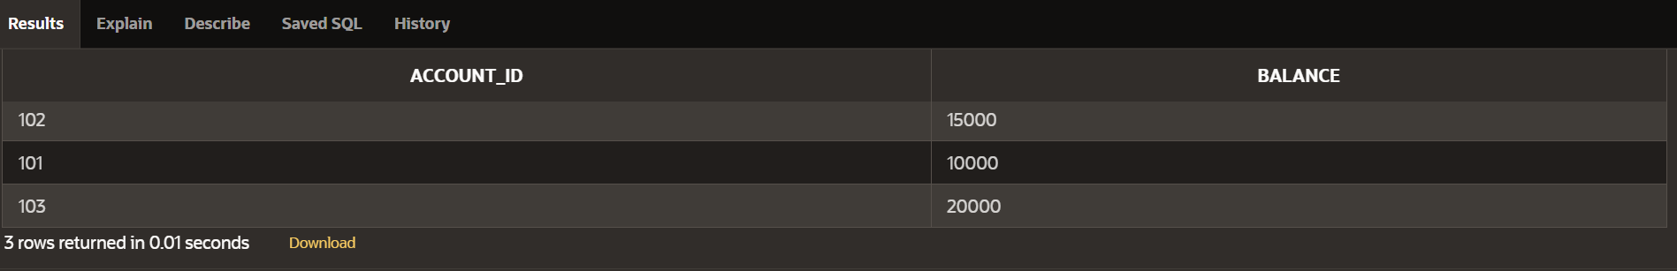

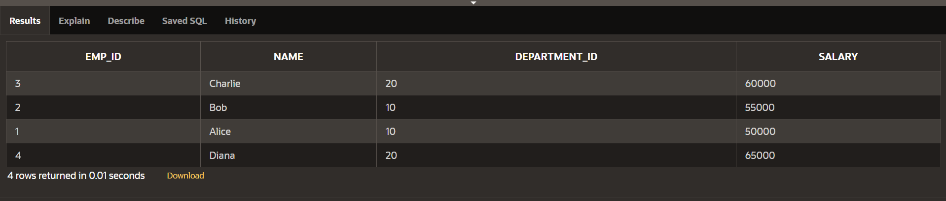

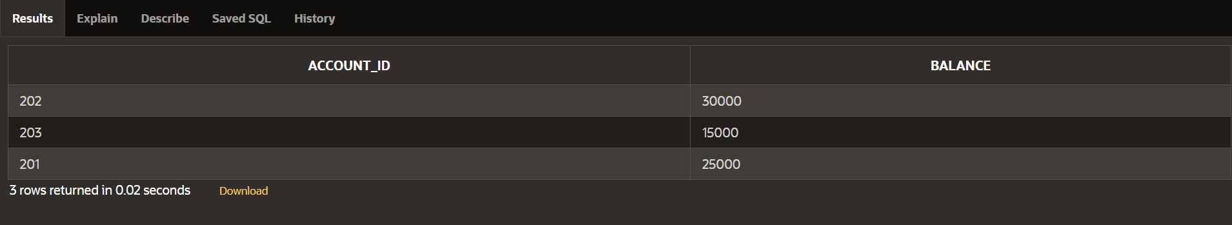

**Scenario 1:** The bank needs to process monthly interest for all savings accounts.

**Question:** Write a stored procedure ProcessMonthlyInterest that calculates and updates the balance of all savings accounts by applying an interest rate of 1% to the current balance.

CREATE OR REPLACE PROCEDURE ProcessMonthlyInterest IS

BEGIN

UPDATE savings_accounts

SET balance = balance + (balance * 0.01);

COMMIT;

END;

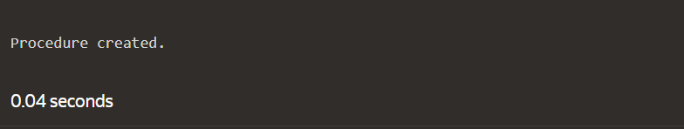

**Scenario 2:** The bank wants to implement a bonus scheme for employees based on their performance.

**Question:** Write a stored procedure **UpdateEmployeeBonus** that updates the salary of employees in a given department by adding a bonus percentage passed as a parameter.

CREATE OR REPLACE PROCEDURE UpdateEmployeeBonus(

dept_id IN NUMBER,

bonus_percent IN NUMBER

) IS

BEGIN

UPDATE employees

SET salary = salary + (salary * (bonus_percent / 100))

WHERE department_id = dept_id;

COMMIT;

END;



**Scenario 3:** Customers should be able to transfer funds between their accounts.

**Question:** Write a stored procedure **TransferFunds** that transfers a specified amount from one account to another, checking that the source account has sufficient balance before making the transfer.

CREATE OR REPLACE PROCEDURE TransferFunds(

from_account_id IN NUMBER,

to_account_id IN NUMBER,

amount IN NUMBER

) IS

insufficient_balance EXCEPTION;

BEGIN

DECLARE

from_balance NUMBER;

BEGIN

SELECT balance INTO from_balance FROM bank_accounts WHERE account_id = from_account_id;

IF from_balance < amount THEN

RAISE insufficient_balance;

END IF;

END;

UPDATE bank_accounts

SET balance = balance - amount

WHERE account_id = from_account_id;

UPDATE bank_accounts

SET balance = balance + amount

WHERE account_id = to_account_id;

COMMIT;

EXCEPTION

WHEN insufficient_balance THEN

RAISE_APPLICATION_ERROR(-20001, 'Insufficient balance in source account.');

WHEN OTHERS THEN

ROLLBACK;

RAISE;

END;



